**PROJECT DESIGN PHASE-II DATA FLOW DIAGRAM AND USER STORIES :-**

|  |  |
| --- | --- |
| Date | 03 October 2022 |
| Team ID | PNT2022TMID37442 |
| Project Name | Project – IOT BASED SAFETY GADGET FOR  CHILD SAFETY AND NOTIFICATION  SYSTEM |
| Maximum Marks | 4 Marks |

|  |  |  |  |  |  |  |
| --- | --- | --- | --- | --- | --- | --- |
| **User Type** | **Functional**  **Requirement (Epic)** | **User Story**  **Number** | **User Story / Task** | **Acceptance criteria** | **Priority** | **Release** |
| Customer  (Mobile user)  and (Web user) | Registration | USN-1 | As a user, I can register my account by entering my email, password, and confirming my password. | I can access my account / dashboard | High | Sprint-1 |
|  |  | USN-2 | As a user, I will receive confirmation email once I have registered myself | I can receive confirmation email & click confirm | High | Sprint-1 |
|  |  | USN-3 | As a user, I can register for the application through apple account | I can register & access the dashboard with apple account Login | High | Sprint-2 |
|  | Login | USN-4 | As a user, I can log into the application by entering user id & password |  | High | Sprint-1 |
|  |  |  |  |  |  |  |
|  |  |  |  |  |  |  |
| Customer Care  Executive | Login |  | As I enter I can view the working of the application and scan for any glitches and monitor the operation and check if all the users are authorized. | I can login only with my provided credentials | Medium | Sprint - 3 |
| Administrator | Login |  | Maintaining and making sure the database containing the locations are secure and accurate and updated constantly. | I can login only with my provided credentials | High | Sprint - 3 |

# DATA FLOW DIAGRAM

Current location with a warning

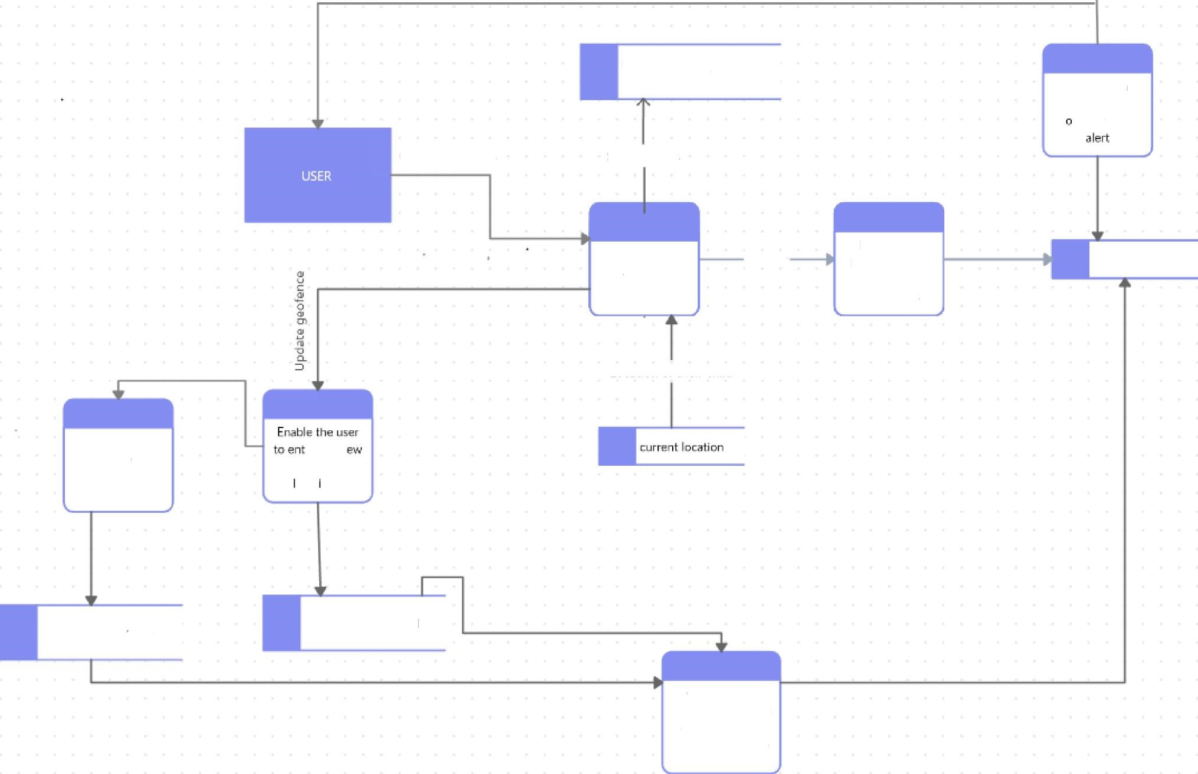

Log

in

credentials

Position

w/iLh

respect

to

the

geDhznce

Safety status

Check with

geofence

,

if

out

f

to

range

Own

Der

account

I

nrat

inn

nf

th

eir

r

hiI+4

History

Display the

location of

the

child

with

timestamps

Recent Ic›catIon

Input

the

safety

range

safety distance iange

er

the

n

geofence

QCdt OFi9

Geofence of tll+ child

Compute the

safety range

based

on

the

recently

updated geofence